|  |
| --- |
| Name: R.G.K.D Amarasooriya |
| Student Reference Number:10707128 |



|  |  |  |
| --- | --- | --- |
| Module Code: SOFT336SL | Module Name: Cross-platform application in C++ | |
| Coursework Title: Calculator | | |
| Deadline Date:  18th of January 2022 | | Member of staff responsible for coursework:  Mr. Marius Varga |
| Programme: | | |
| Please note that University Academic Regulations are available under Rules and Regulations on the University website [www.plymouth.ac.uk/studenthandbook](http://www.plymouth.ac.uk/studenthandbook). | | |
| Group work: please list all names of all participants formally associated with this work and state whether the work was undertaken alone or as part of a team. Please note you may be required to identify individual responsibility for component parts.  ***We confirm that we have read and understood the Plymouth University regulations relating to Assessment Offences and that we are aware of the possible penalties for any breach of these regulations. We confirm that this is the independent work of the group.***  Signed on behalf of the group: | | |
| Individual assignment: ***I confirm that I have read and understood the Plymouth University regulations relating to Assessment Offences and that I am aware of the possible penalties for any breach of these regulations. I confirm that this is my own independent work.***  Signed: Kanchana Dilrukshi | | |
| Use of translation software: failure to declare that translation software or a similar writing aid has been used will be treated as an assessment offence.  I *have used/not used translation software.  If used, please state name of software………………………………………………………………… | | |
| **Overall mark _____% Assessors Initials ______ Date_________** | | |

*Please delete as appropriateSci/ps/d:/students/cwkfrontcover/2013/14

SOFT336SL

**Cross-Platform Application Development in C++**

**Simple Calculator**

Contents

Description of The Project 5

Introduction 5

Scope 5

Functionalities 5

Supported Platforms 6

Future Improvements 7

Technical Details 8

GUI Design 8

Implementation Details 9

Design of UI 12

Resources 13

# Description of The Project

## Introduction

I created a simple calculator using c++ with QT. It’s a cross platform application. I created components of this application using qt libraries.

## Scope

This is a simple calculator which can perform basic operations like adding, multiplying, dividing, and dividing numbers.

## Functionalities

This application allows user to:

* Add number
* Subtraction
* Multiply
* Division
* Clear inputs
* Plus, or minus functions
* Use decimals

## Supported Platforms

Windows 11

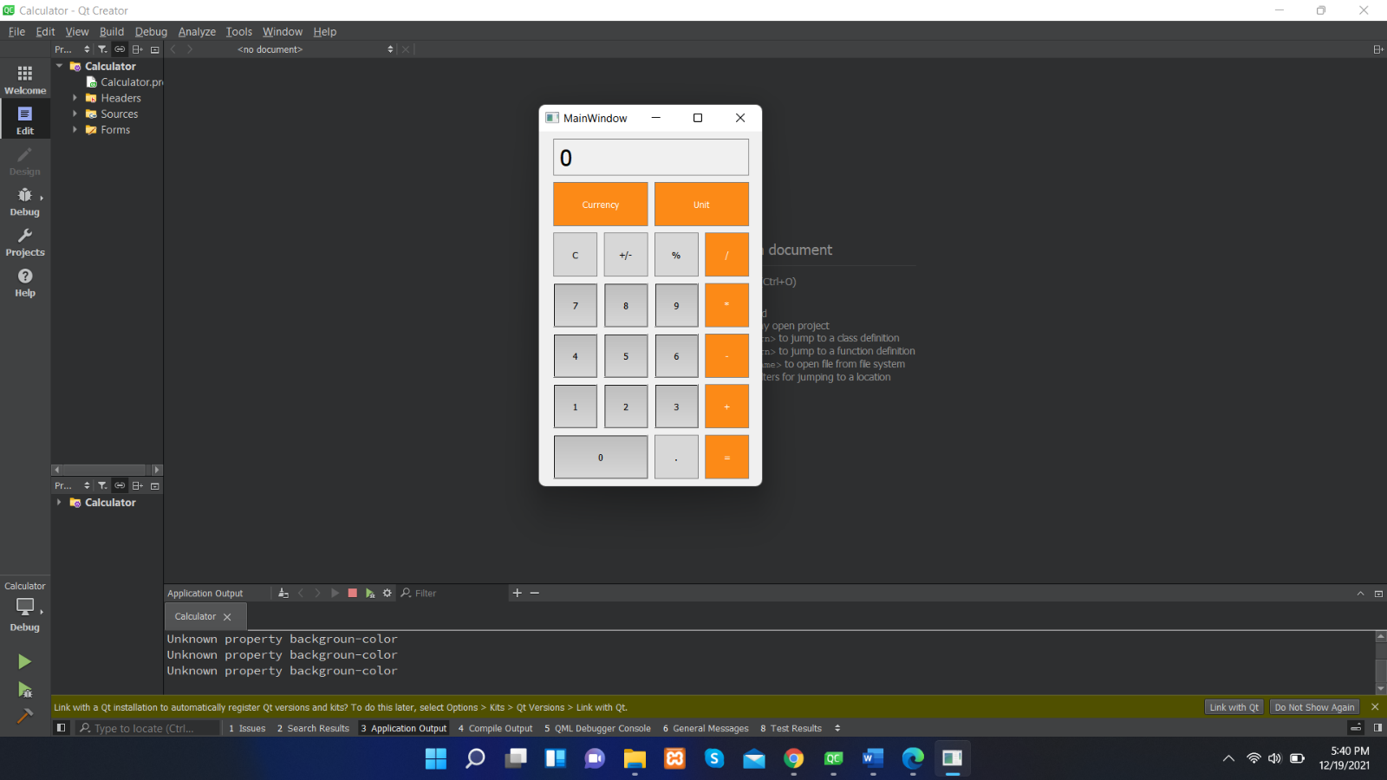There is no error. Project runs very well.

## Future Improvements

I already added two buttons to this calculator which is called currency and unit. Those two are for calculate currency and get different measurements.

* + Add currency converter
  + Add unit converter

*“Obtain real-time, accurate and reliable currency exchange rate data for hundreds of worldwide currencies, updated as often as every 60 seconds.”*

Because of this reason, I won’t be able to add currency converter, therefore I make it as a future. Though I can give rates from this website(<https://exchangeratesapi.io/>), it’ll be continuously changing time to time. Therefor I need proper mechanism to update the system with current changes. In this situation it’s a challenge to me.

# Technical Details

## GUI Design

Currency Converter

# Implementation Details

Add functions for button functions such as addition, multiplication, division, and other functions.

Signal and slots for button functions.

This calculator gets 15 number of inputs. Its in a range of 15 numbers.

Functionality of +/- operation button and “.” Decimal point operation button.

Functionality of clear “c” operation button and equal “=” operation button.

# Design of UI

# Resources

Here are the resources I used to build this application other than the lecture materials and recordings.

<https://youtu.be/FhV1ZEVNK08>

<https://www.youtube.com/watch?v=EkjaiDsiMQ&list=PLS1QulWo1RIZiBcTr5urECberTITj7g>

<https://www.youtube.com/watch?v=F56fSKoNCtk&list=PLS1QulWo1RIZiBcTr5urECberTITj7gjA&index=5>